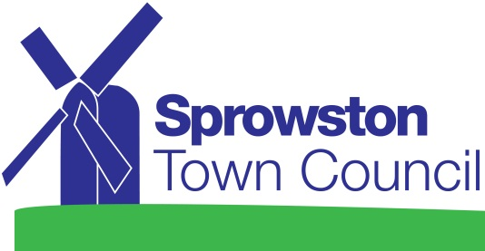

APPLICATION FOR FINANCIAL ASSISTANCE

- Name of Organisation:

- Name and address of correspondent (and office held):

- What are the objectives of your organisation?

- Is membership/support open to any resident of Sprowston, regardless of sex, age, ethnic origin, religion, disability or sexual orientation? If not, please give reason:

- Amount of grant applied for £

- Purpose for which the money will be used. Please explain clearly and simply the reason for your request.

- Have you applied for grant aid to any other organisation (including local authorities)? If so, to whom (please give details of the decision on your application):

- Is there anything else you wish the Town Council to take into account when considering this application?

- Please ensure that you have attached up to date examined accounts in support of this application.

I agree to the Principles of Grant Aid as set out by Sprowston Town Council

Signed Dated
Consent Form
Your privacy is important to us and we would like to communicate with you regarding your application for financial assistance. To do so we need your consent. Please confirm your consent. You can find out more about how we use your data from our “Privacy Notice” which is available from our website or from the Council Office at Sprowston Recreation Ground, Recreation Ground Road Sprowston, Norwich, NR7 8EW (01603 408063).

- Yes, please, I would like to receive communication by telephone / post / email

Signed ______________________________ dated ___________________

